CERTIFICATE

Certified that this project title “**ONLINE UNITY CLUB REGISTRATION & INTERACTON SYSYEM**” is Product of Mister Bagirishya Rwema Dominique who carried out the research under my supervisor Eng. Murenzi Deudone. Certified further that to the best knowledge the work report here in does not form part of any other project report on the basis of which a degree or award was conferred on an earlier occasion on this or any other candidate.

………………………………………….. …………………………………………….

Signature of the supervisor signature of H.O.D

Eng. MURENZI Deudone Eng.(Mr.). NTEZIYAREMYE Gaston

# Date………/…….../2017.

**DECLARATION**

I declare this project work entitled **UNITY CLUB ONLINE REGISTRATION & INTERACTON SYSYEM**”**, case study: “UNITY CLUB OF RWANDA”** is completely my own work and has not been published or submitted for any other award of any other school before and up to now. and I declare that this report has been produce as a result of personal effort with technical support from my supervisor and is fully and my original work.

It is the work of **BAGIRISHYA Rwema Dominique** from my knowledge and research where by other scholar’s writings were cited and references provided in chapter II.

In thus declare that this work is mine and was completed successfully under the supervision of

**Eng. Murenzi Deudone.**

**Bagirishya Rwema Dominique**

signature…………………………………….

# 

**DEDICATION**

I dedicate to GOD.

I dedicate to my Parents.

I dedicate to my Teachers.

I dedicate to all my relative family.

Idedicate to my friends and colleges.

**ABSTRACT**

This project describes my own implementation of “**Online** **Unity Club Registration & Interaction System**”. I used the Entity-Relationship model to design database that will store and organize the membership’s data and Administration’s Data. I have also used PHP package to provide the user graphical interface that is sensitive and easy to use. PHP is being widely used for developing different types of applications and performing various types of jobs. In addition, it also provides the means of associating the user written logically defined code with the components used in a project.

My project is called **Online** **Unity Club Registration & Interaction System**” concerned with the interaction of membership and Administration of Unity club. This project will be providing easier, friendly and effectively manner to manipulate this system.

In general, *Online Unity Club Registration & Interaction System* about Unity Club based Rwanda is working as for helping Rwandan mainly members of unity club to get full information about their Daily works and can emit them to hold online conversation or chatting.

This project will offer software that can be used in helping the members so that they can use their created accounts to view what they have been told and to participate in club conversation room.

**ACKNOWLEDGEMENT**

It is on realization of such a piece of knowledge that, we wish to acknowledge for a given help for us in this course of producing this project. Through not at all can be acknowledged, the following deserve special mention and gratitude.

Words are not enough to express our deepest appreciation to the alight God who has guided us through our lives and studies and all. I also grateful to my parents, brothers and sisters my classmates and colleagues for their beautiful help.

I also grateful to thank my supervisor **Eng. MURENZI Deudone** for his guidance, advises and valuable knowledge. Special thanks to all College Acej/Karama teaching staffs especially in department of computer science for the guidance and assistance they gave me throughout my studies.

I will always be grateful to GOD for all mentioned above.

**Almighty God bless you All!**

TABLE OF CONTENTS

CHAPTER I. GENERAL INTRODUCTION 1

I.1. INTRODUCTION 1

I.2. BACKGROUND OF THE STUDY 1

I.3. PROBLEM STATEMENT 2

I.4. Interest of the study 2

I.4.1. Personal interest 2

I.4.2. Society interest 2

I.4.3. SCIENTIFIC INTEREST 2

I.5. SCOPE OF STUDY 2

I.6. HYPOTHESIS OF THE STUDY 3

I.7. OBJECTIVES 3

I.7.1. GENERAL OBJECTIVE 3

I.7.2. SPECIFIC OBJECTIVE 3

I.7.3. Organization of the study 4

CHAPTER II. ANALYSIS OF EXISTING SYSTEM AND LITERATURE REVIEW 5

II.1. Introduction 5

II.2.1. System 5

II.2.1.1. System Analysis 5

II.2.1.2. Existing System Analysis 5

II.2.1.3. Proposed System 5

II.2.1.4. Proposed system Requirements 6

II.2.2. Information 6

II.2.3. Information Technology 6

II.2.4. Information System 6

II.3. Information system and fundamentals 6

II.3.1. System 6

II.3.2. Information 7

II.3.3. Information system 7

II.3.4. Information technology 7

II.3.5 Database 7

II.3.6 Entity 7

II.3.7 Table 7

II.3.8 Primary key 7

II.3.9 Foreign key 7

II.4. Database concepts 8

II.4.1. Data 8

II.4.2. Database 8

II.4.3. Entity 8

II.4.4. Table 8

II.4.5. Record 8

II.4.6. Field 8

II.4.7. Data type 8

II.4.8. Attribute 8

II.4.9. Key 9

II.4.10. Relational database 9

II.4.11. Database management system 9

II.5. Tools used 9

II.5.1 A database management system (DBMS) 9

II.5.2 WEB BROWSER 9

II.5.3 XAMPP 9

II.5.4 HTML 9

II.5.5 SUBLIME 10

II.5.6 PHP 10

II.5.7 CSS 10

II.5.8 APACHE 10

II.5.9 TEXT EDITOR 10

II.5.10 Why use PHP and MySQL? 10

II.6. ADVANTAGE OF DATABASE 11

CHAPTER III: RESEARCH METHODOLOGY 12

III.1 introduction 12

III.2. Research Methodology 12

III.2.1. Introduction 12

III.2.2. TECHNIQUES USED IN DATA COLLECTION 12

III.2.3. INTERVIEW 12

III.2.4. OBSERVATION 12

III.2.5. INTERNET 12

III.2.6. SOFTWARE DEVELOPMENT PROCESS 12

III.2.7. Waterfall Model 12

III.2.8: Advantages of waterfall model 14

III.2.9: Disadvantages of waterfall model 15

III.3. MODELING LANGUAGE (UML) 17

III.3.1. Definition 17

III.3.3. DATA DICTIONARY AND RELATIONSHIP 17

III.3.3.1 Data dictionary 17

III.3.3.2 ERD (Entity relationship diagram) 20

CHAPTER IV: SYSTEM IMPLEMENTATION AND RESULTS 21

IV.1 Introduction 21

IV.2 Technologies used 21

IV.2.1 Software Tools 21

IV.2.2 Hardware Tools 21

IV.3. The Html Page for the System 22

IV.3.1. Home page of this system 22

CHAPTER V. CONCLUSION AND RECOMANDATION 28

V.1 Conclusion 28

V.2 Recommendations 28

LIST OF FIGURES

Figure 1water fall development model 13

Figure 2system design 16

Figure 3 diagram(ERD) 20

Figure 4homepage 22

Figure 5registration form 23

Figure 6registered member successes and getting CARD 24

Figure 7unknown information of member that failed to loggin 25

Figure 8 administratior failed to loggin becouse the information is unknown. 25

Figure 9 members list 26

Figure 10member in who is logged in is in charting room 27

LIST OF ABBREVIATION

DBMS: Data Base Management System

SQL: Structure Query Language

XAMPP: Extended Apache MySQL PHP PERL

PHP: Hypertext Preprocessor

HTML: Hyper Text Markup Language

CSS: Cascading Style Sheet

RAM: Random Access Memory

HDD: Hard Disk Drive

**TOPIC: UNITY CLUB ONLINE REGISTRATION AND INTERACTION SYSTEM**

**CASE STUDY: UNITY CLUB RWANDA**

# CHAPTER I. GENERAL INTRODUCTION

## I.1. INTRODUCTION

Nowadays, in different condition, technology systems show that ICT plays the greatest role about the development of the countries even whole world. The developers develop their systems in order to replace manual systems and to simplify work in different sectors such as: sharing information and communication, commerce, education, medical, school, bank and other. In this case Unity Club need the New Advanced system of informing and promoting the relationship between memberships and administration (leaders) in club. To receive more information about their daily works and activities, to bring the official numbers of club members and important thing it will allows the all club participants to make online meetings by using this system.

However, over Rwanda we all need simple communication in all states of regions of the country to accurate the Development of Rwanda. Especially in Unity Club as benefit club to all Rwandan. Faced with this reality, it is very important to use the new system of online system in order to facilitate unity club avoid to waste their assets when announcing their club tours and meeting schedules in social medias in order to inform their members.

Recognizing this problem is for this regarding that there is a need of technology system in order to provide online meetings and to inform memberships everything in deed. with this system it will

also help the unity club to avoid spending money when they have something want to share or to announce to the members.

in spite of using social medias like radios or televisions, me I prefer to design this system so that can provide full interaction between members and administration in unity club.

## I.2. BACKGROUND OF THE STUDY

Unity Club is the part of department in Ministry of Unity and Reconciliation in Rwanda that especially concerned for Improvement of unite of Rwandan in all every states.

This Unity Club is also one of the strong club that perform great function in the country. all in Rwandan base of Unity that concerned for the unity of every Rwandan to resolve this problem is to use computerized system like Unity Club Interaction System.

## I.3. PROBLEM STATEMENT

### Today there is no current system that could register and manage all unity club members.

1. It is not easy to announce something to all memberships of unity club.
2. There is no way of sponsors to support the Unity club.
3. The social medias that support interaction of members, is based on members that was still Known themselves. EX: WhatsApp or Facebook groups of Unity Club who studied in College Acej Karama. (these groups will interact members of unity club who studied in college Acej/Karama only. Not to all members of whole country).
4. No management of members by administration of Unity Club.

## I.4. Interest of the study

## I.4.1. Personal interest

The interest of the researcher in this project is to enhance and develop his programming skills and make practice of what was leant in class.

## I.4.2. Society interest

To put into the practice, the Government policy of using online systems in case of avoiding to waste the time during communicating each other.

## I.4.3. SCIENTIFIC INTEREST

This project will be a model reference for further researchers. Based on this, they will develop more efficient software.

## I.5. SCOPE OF STUDY

This project is concerning computerization of **“UNITY CLUB ONLINE REGISTRATION AND INTERACTION SYSTEM.”** But it is not in charge of the entire department consisting this topic; it is only scoped on informing and interacting concerned especially the people who make registration and getting more information about the club they have been signed up.

## I.6. HYPOTHESIS OF THE STUDY

It is possible to implement a computerized system that contributes to the easy registration system based on the people want to make registration and getting result of the exam through it along the day and any time needed.

## I.7. OBJECTIVES

## I.7.1. GENERAL OBJECTIVE

The main objective of this project is to help Unity Club administration or Leaders to Get

simple way of informing to memberships their daily activates such like; date a such activity will take place on, the start and end time of that activity, the place where it will be accrued and also to bring members full schedule about club meeting.

Second is to setup the way to sponsors and volunteers who want to support this club a place of giving their information.

Third one is to promote a relationship in all members using online SMS charting. The room found in this system when you are logged in as a member.

## **I.7.2. SPECIFIC OBJECTIVE**

* To allow people who want to become a member of Unity club to be registered using online system.
* To give the Memberships more information about their club tours and meetings schedules from Administration of Unity Club.
* To promote the interaction of all members of country using SMS charting found in this system, in way of decreasing even to remove many groups of Facebook or WhatsApp created by unity club members to interact. (this will require to register as a member in this system. shown in chap 4).
* To set up away for sponsors to find easy way of supporting unity club.
* To count and give the official numbers of members of Unity Club.

## I.7.3. Organization of the study

This work is organized into 5chapters:

**Chapter 1:** General Introduction, this chapter focuses on Objectives of the project, Problem statement, and Interest of the project, Scope, Hypothesis and Methodology of the project.

**Chapter 2:** Analysis of Existing system and literature review, this offers theoretical concepts, fundamentals tools and languages that support the project and used during the development of the Project.

**Chapter 3:** Research Methodology; this will focus on software development methodology that can be used on the project and the data gathering techniques that are made.

**Chapter 4:** Analysis, Design and Implementation, the chapter is formed by analysis and the development of the project.

**Chapter 5:** The last chapter is made up of the conclusion and recommendation for further improvements of the software design.

# CHAPTER II. ANALYSIS OF EXISTING SYSTEM AND LITERATURE REVIEW

## II.1. Introduction

The purpose of this chapter is to give a brief description about the terms that are used during the development. It deals with theoretical concepts and fundamentals that support this project, it provides definitions and characteristics of technologies used in this project, it analyzes how manual system is current working and the how proposed system is better to it and how it will work. This overview on the concepts serves as the root that leads to the development of Unity Club Online registration and Interaction System.

## II.2.1. System

System is a set of related components or elements that produces a specific result. To develop a system there are to required components: System Analysis and system Design.

## II.2.1.1. System Analysis

## II.2.1.2. Existing System Analysis

In Rwanda most of the clubs have no systems that can register their members using online Systems. And also the administration of these clubs use social medias to publicize something to their members, such us radios and televisions announcements. And the third one, members of that club in all country have no way to communicate. The members that are able to communicate are members that was still known themselves example: members of unity club live in same district, members that studied together or work together. these members themselves create Facebook or WhatsApp groups in a way of communicate. (but these groups are not belonging to whole country so that every member of club in country can participate in it), it belongs to the groups of people belongs together, work together or live together and so on. in case Unity Club is located in this manual system.

## II.2.1.3. Proposed System

This the new system will facilitate people who want to register in unity club to easy way using online system. and to get full information about the club activities. It will also promote the interaction of all members in whole country to communicate using online charting room (conversation room) after to create accounts (or registering) in this system.

The last is to give easy way to sponsors to support club.

## II.2.1.4. Proposed system Requirements

* **Software requirements**
* Internet browser software such as Internet Explorer, Mozilla Firefox, Google chrome etc.
* Microsoft windows.
* Internet (Network).
* Smart Phones
* **Hardware requirement:** The following are minimum hardware requirements for accessing this software:
* 2GB RAM
* 2GB Processor
* 320GB free space of Hard Disk (for PCS) and 8GB (for Smartphones).

## II.2.2. Information

Information is defined as data that have been manipulated and can be presented in a form suitable for human interpretation.

## II.2.3. Information Technology

Information technology is a term that describes the combination of computer technology (hardware and software) with telecommunication technology (data charting, image, and voice networks).

## II.2.4. Information System

A set of people, data, processes, and information technology that interact to collect, process, store, and provide as output the information needed to support an organization.

## II.3. Information system and fundamentals

### II.3.1. System

A collection of components that work together to realize some objective forms a system. Basically there are three major components in every system, namely input, processing and output. In a system the different components are connected with each other and they are interdependent. For example, human body represents a complete natural system. We are also bound by many national systems such as political system, economic system, educational system and so forth. The objective of the system demands that some output is produced as a result of processing the suitable inputs.

### II.3.2. Information

This term defined as a processed data or means the data after manipulation by the computer. To be manipulated it requires 3 phases: Input, Processing and output.

### II.3.3. Information system

An arrangement of people or procedure that interact together to collect or produce the output information needed to support an organization.

### II.3.4. Information technology

Information technology means the combination of software and hardware such like images, data, voices with the purpose of communicating.

### II.3.5 Database

A database defined as a collection of related data that is organized so its contents easily to be accessed, managed and updated.

### II.3.6 Entity

As Scientist we explain that the entity is a type of element (object, individual) of real word. means is an object that exist & distinguishable from other object.

### II.3.7 Table

A table defined as a collection of records each record is in form of table. Table consists of rows and columns. Here we can say that a database is a collection of tables.

### II.3.8 Primary key

Primary key is special database column designed to uniquely identify rows from tables. On primary key the rule state that each table must have its own primary key that is unique and not null.

### II.3.9 Foreign key

Foreign key is a primary key that related in another table. Means it used in a reference for another table/entities.

## II.4. Database concepts

### II.4.1. Data

Data is information that is waited to be manipulated by the computer to be changed in form that is suitable to human interruption called information.

### II.4.2. Database

A database defined as a collection of related data that are organized so these records can be easily accessed, managed and updated.

### II.4.3. Entity

A person, place, object, event, or concept in the user environment about which the organization wishes to maintain data.

### II.4.4. Table

A table defined as a collection of records each record is in form of table. Table consists of rows and columns. Here we can say that a database is a collection of tables.

### II.4.5. Record

A Record is a generic term for a 'row' in the database, just like a card. A record very often represents a 'piece' of content. The dynamic functionality and much of the content of Mambo relies on a database in order to function.

### II.4.6. Field

The location in a database record reserved for a particular type of data; for example, in a library catalog, author, title, subject headings would all be stored in specific fields.

### II.4.7. Data type

A description on a field that determines what kind of information you can enter in the field. Field data types include Text, Memo, and Number. In general, the field size is characterized with field name, data type and field size, means what text, memo and number in MS Access are made of: Field name Data type ex (name: Rwema Datatype: Varchar).

**Date:** calendar dates which can be manipulated mathematically

**Logical:** True or False, Yes or No

### II.4.8. Attribute

A named property or characteristic of an entity that is of interest to the organization.

### II.4.9. Key

Key or key field are a field (or fields) on the many side of a one-to-many relationship between tables that related to a primary key of the other table. Foreign key does not need to be unique within the table. Key consists of primary and foreign key as explained above.

### II.4.10. Relational database

Relational database builds the relationships between fields in tables explicitly through keyed fields.

### II.4.11. Database management system

Database management system explained as software package to facilitate the creation and maintenance of computerized database. DBMS consists of collection of interrelated of data and collection of a set of programs to access that data.

## II.5. Tools used

### II.5.1 A database management system (DBMS)

Consists of collection of interrelated data and a set of programs to access that data. It is software that is helpful in maintaining and utilizing a database.

MySQL is a freely available open source Relational Database Management System (RDBMS) that uses Structured Query Language (SQL). SQL is the most popular language for adding, accessing and managing content in a database. It is most noted for its quick processing, proven reliability, ease and flexibility of use.

### II.5.2 WEB BROWSER

A web is a software application for retrieving and presenting information resources on the World Wide Web.

### II.5.3 XAMPP

XAMPP is free and open source cross plat form web server solution stock package consisting mainly of the apache HTTP server, MYSQL database, and interpreters for scripts written in the PHP and Perl programming languages.

XAMPP `S IS STANDS FOR

X: extended A: apache M: MySQL P: PHP and P: Perl.

### II.5.4 HTML

**Hypertext Markup Language** (**HTML**) is the main markup language for displaying web pages and other information that can be displayed in a web browser.

HTML is written in the form of HTML elements consisting of *tags* enclosed in angle brackets (like <html>), within the web page content. HTML tags most commonly come in pairs like <h1> and </h1>, although some tags, known as *empty elements*, are unpaired, for example <img>. The first tag in a pair is the *start tag*, the second tag is the *end tag* (they are also called *opening tags* and *closing tags*). In between these tags web designers can add text, tags, comments and other types of text-based content.

### II.5.5 SUBLIME

Sublime is the quality of greatness means a grateful text editor where we found every states such like physical, calculation and other php functions used to build a system. Today I use SUBLIME Text Build 3126 Version.

### II.5.6 PHP

PHP is a server-side scripting language designed for web development but also used as a general-purpose programming language.

### II.5.7 CSS

CSS is a style sheet language used for describing the look and formatting of a document written in a HTML.

## II.5.8 APACHE

The Apache HTTP Server, can be defined as a Web server application notable for playing a key role in the initial growth of the World Wide Web. Originally based on the NCSA Http server, development of Apache began in early 1995 after work on the NCSA code stalled.

### ****II.5.9**** ****TEXT EDITOR****

Text editor is a computer program that permits the creation and editing of stored text. In every operating system you’ll find a text editor. In windows for example you can use Notepad. The important thing is that your editor can save standard texts. You don’t have to save any additional control commands such as bold, tables, or justify. If your editor can do this, then it is well suited for HTML programming.

## ****II.5.10**** Why use PHP and MySQL?

PHP and MySQL combine to be an easy powerful way to create dynamic web pages that actually interact with your visitors. HTML can create useful and well formatted web pages. With the addition of PHP and MySQL you can collect data from your users, create specific content on the fly, and do many other things that HTML alone can't do.

The beauty of PHP as a language is that it is designed to be used along with HTML.

You can use PHP right inside your already existing HTML content, or put HTML tags right inside your PHP coding. When learning PHP, you are not making your existing HTML knowledge obsolete, you are instead adding to it to give it more functions and abilities.

## II.6. ADVANTAGE OF DATABASE

**To hold data in database is functional as shown below.**

Here there is a several advantages of using database as am going to explain: first to use database give access to data in a simple way. Means to get access to data located in database is so simple. Second one to handle the data presented in database such as to insert data, delete data, updating data and the other queries that are available to be handled in database. And other is to authorize multiple users to access to information or records found in database. Such example is how this system will work: the member will create account and after will get access to login in way accessing club information.

# CHAPTER III: RESEARCH METHODOLOGY

## III.1 introduction

The methodology may refer to set of methods or procedures and rules and even steps followed in planning, defining, building, testing and implementing a system.

## III.2. Research Methodology

### III.2.1. Introduction

Several different approaches are being used in software development progress, such as waterfall model, prototyping and techniques used to collect data etc. For this project, the as a researcher I used a waterfall model.

## III.2.2. TECHNIQUES USED IN DATA COLLECTION

In my research I used three techniques in data collection: interview, Observation and Internet. These techniques give good output when they are used together to complement one another.

## III.2.3. INTERVIEW

This is the technique where system analyst collects information from someone face to face

## III.2.4. ****OBSERVATION****

Technique a researcher uses to collect information about an organization when he/she is using his/her eyes and looking day to day the work of existing system of an organization he wants to develop for new system.

## III.2.5. INTERNET

For internet allow you to search information According to your need without moving place for going asking people in charge of case study.

## III.2.6. SOFTWARE DEVELOPMENT PROCESS

The Software development process methodology that will be used is the waterfall model. This is a sequential software development model of five phases:

### III.2.7. Waterfall Model

A set of activities followed by order. And in waterfall development we move to next step of development if the previous step completed successfully. In waterfall model development one phase starts only when the previous phase is complete.

Diagram that shows waterfall life process

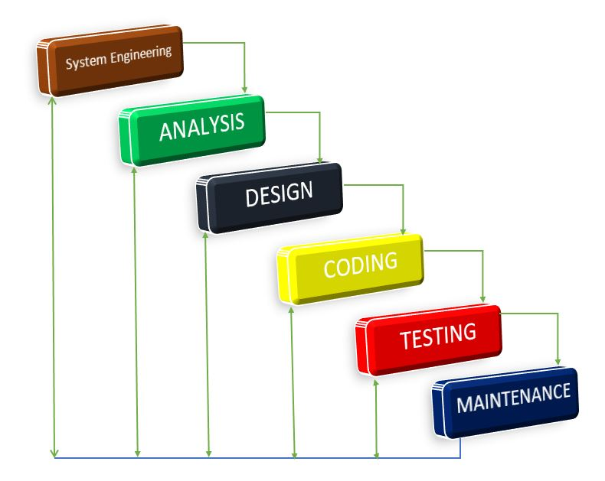

Figure 1water fall development model

All these phases are cascaded to each other so that second phase is started as and when defined set of goals are achieved for the first phase and it is signed off, hence the name waterfall model.

* **System engineering:** to develop requires engineers
* **Requirements analysis**
* All possible requirements of the system to be developed are captured within this phase. Requirements are set of functionalities and constraints that the end-user who will use the system expects from the system.

The requirements of the system have been identified using a type diagram called use case diagram.

* **System and software design**

Before starting for actual coding, it is highly important to understand what is going to be created and what it should look like. The requirements specifications from first phase are studied in this phase and system design is prepared. System design helps in specifying hardware and system requirements and also helps in identifying overall system architecture. The system design specification serves as input for the next phase of the model.

* **System coding**

After reaching to the design of software you start coding, this stage contains the action that will correspond to the form you have design, so this is also important stage because can join an interface to the database means without coding process or stage nothing you gain from database.

* **Implementation and Unit testing**

On receiving system design documents, the work is divided in model/units and actual coding is started. The system is first developed in small programs called units, which are integrated in the next phase. Each unit is developed and tested for its functionality; this is referred to as Unit Testing. Unit testing mainly verifies if the modules/ units meet their specification.

* **Operations and maintenance**

This phase of the waterfall model is virtually never ending phase (Very long). Generally, problems with the system developed (which are not found during the development life cycle) come up after its practical use starts, so the issues related to the system are solved after deployment of the system. Not all the problems come in picture directly but they arise time to time and need to be solved; hence this process is referred as maintenance.

### III.2.8: Advantages of waterfall model

To use waterfall development model, has good benefits as shown below:

* **Waterfall model is very good approach for small projects**: such like example these final year projects are not concerned as large systems; to use waterfall model is very grateful in order to indicate and present your developed system in such few minutes.
* **Easy to use and to understand:** this is other good advantage of using waterfall model because it doesn’t require many words to explain the system. and also here someone who is being explained the will understand easily how the system will work.
* **Each phases completely developed**: this is the other factor to use waterfall model because you cannot jump the phase while the first or previous is not compete.
* **Easy to manage**: means to manage the project is very simple when there is presence of waterfall model it is good approach in management of the system.
* **Cost Effective:** here to use waterfall model requires northing.

### III.2.9: Disadvantages of waterfall model

* Once an application is in the [testing](http://istqbexamcertification.com/what-is-a-software-testing/) stage, it is very difficult to go back and change something that was not well-thought out in the concept stage.
* No working software is produced until late during the life cycle.
* High amounts of risk and uncertainty (high risked model).
* Not a good model for complex and object-oriented projects.
* Poor model for long and ongoing projects. (not very useful for large project).
* Not suitable for the projects where requirements are at a moderate to high risk of changing.

## 

**index**

Club Sponsors

Change ADMIN names

Change ADMIN Password

Change Account Password

Change Names & Username

Sender Message

Sender Name

Delete Sponsors

View Sponsors

SETTINGS

Feedbacks

Manage Members

Send Messages & Posts

ADMINISTRATION

Edit Your Account

Timetable Tour

**MEMBER ACCOUNT**

Conversation Room

Change Profile Pic

income messages from administration

Requirement

Gathering

CONTACT US

HOME

ADMINISTRATION

SPONSOR

CLUB NEWS

MEMBERSHIP

WELCOME PAGE

REGISTERETION PAGE

CONTACT US PAGE

SPONSOR REGISTRATION PAGE

NEWS PAGE

MEMBER CARD

LOGIN PAGE

View Members

Delete Members

Delete Posted Messages

Figure 2system design

## III.3. MODELING LANGUAGE (UML)

### III.3.1. Definition

The UML is an industry standard modeling language with a rich graphical notation, and comprehensive set of diagrams and elements used for visualizing, specifying, constructing, and documenting the artifacts of a software-intensive system.

## ****III.3.3. DATA DICTIONARY AND RELATIONSHIP****

### III.3.3.1 Data dictionary

Table 1: users

Primary key: ID

|  |  |  |  |
| --- | --- | --- | --- |
| **Field name** | **Data type** | **Description** | **Constraint** |
| id | DECIMAL | member id | Primary Key |
| fname | VARCHAR | member first name |  |
| lname | VARCHAR | Member Last name |  |
| username | VARCHAR | Member username |  |
| phone | VARCHAR | Member phone |  |
| sex | VARCHAR | Member sex |  |
| district | VARCHAR | Member district |  |
| province | VARCHAR | Member province |  |
| password | VARCHAR | Member password |  |
| repassword | VARCHAR | Confirm-password |  |

Table 2: admin

Primary key: id

|  |  |  |  |
| --- | --- | --- | --- |
| **Field name** | **Data type** | **Description** | **Constraint** |
| Id | INTEGER | Admin id | Primary key |
| fname | VARCHAR | Admin first name |  |
| lname | VARCHAR | Admin last name |  |
| username | VARCHAR | Admin username |  |
| password | VARCHAR | Admin password |  |
| repass | VARCHAR | Confirm password |  |

Table 3: meeting

|  |  |  |  |
| --- | --- | --- | --- |
| **Field name** | **Data type** | **Description** | **Constraint** |
| id | INTEGER | Chart Id | Primary key |
| name | VARCHAR | Chatter name |  |
| message | VARCHAR | Chatter message |  |

Table 4: schedule

|  |  |  |  |  |
| --- | --- | --- | --- | --- |
| **Field name** | **Data type** | **Description** | **Constraint** | |
| Postnumber | INTEGER | Schedule Id | Primary key | |
| actname | VARCHAR | Activity Name |  | |
| actdate | VARCHAR | Activity Date |  | |
| Actstart | VARCHAR | Activity starting time |  | |
| Actplace | VARCHAR | Activity Place |  | |
| Actlocation | VARCHAR | Activity Area or Zone | |  |

Table 5: sponsor

Primary key: ID

|  |  |  |  |
| --- | --- | --- | --- |
| **Field name** | **Data type** | **Description** | **Constraint** |
| id | INTEGER | Sponsor id | Primary key |
| names | VARCHAR | Sponsor Full names |  |
| mail | VARCHAR | Sponsor E-mail |  |
| Address | VARCHAR | Sponsor Address |  |
| country | VARCHAR | Sponsor Country |  |
| sex | VARCHAR | Sponsor Sex |  |
| work | VARCHAR | Sponsor Work |  |

Table 5: send

|  |  |  |  |  |
| --- | --- | --- | --- | --- |
| **Field name** | **Data type** | **Description** | **Constraint** | |
| id | INTEGER | Post id | Primary key | |
| activitymean | VARCHAR | Activity briefly Meaning | |  |

Table 5: Back

|  |  |  |  |
| --- | --- | --- | --- |
| **Field name** | **Data type** | **Description** | **Constraint** |
| id | INTEGER | Post id | Primary key |
| name | VARCHAR | Commenter Name |  |
| idea | VARCHAR | Commenter Message |  |

### 

### III.3.3.2 ERD (Entity relationship diagram)

**M**

FEEBACKS

sponsor

**M**

Delete

manage

**1**

**M**

**1**

USERS

**M**

ADMIN

SEND IN

**M**

­

**M**

truncate

**11**

**M**

**M**

Send/ Delete

view

MEETING

**M**

**M**

**M**

**M**

SendPost

SCHEDULES

Figure 3 diagram(ERD)

# CHAPTER IV: SYSTEM IMPLEMENTATION AND RESULTS

## IV.1 Introduction

This chapter, we explain the new system with new concept of how the application has been conceived and also we will try to explain technologies applied to build. This chapter contains tools used for the development of this application and means of test used in order to be sure with the accuracy of its performance.

## IV.2 Technologies used

To develop the **ONLINE UNITY CLUB REGISTRATION & INTERACTION SYSTEM,** I used many tools that bellows:

### IV.2.1 Software Tools

The system software will be a WINDOWS 8.0 64bit based application with:

* **Editor:** SUBLIME AND DREAMWEAVER CS6
* **OS Platform:** WINDOWS 10 64bit
* **DBMS**: MYSQL
* **Server:** XAMPP, WAMPP
* **Browser:** GOOGLE CHROME
* **Photo Manipulation Software:** ADOBE PHOTOSHOP.

### IV.2.2 Hardware Tools

* **Personal Computer:** Laptop
* **PROCESSOR:** 2GHz
* **RAM:** 2GB
* **Internal HDD:** 320GB

## IV.3. The Html Page for the System

### IV.3.1. Home page of this system

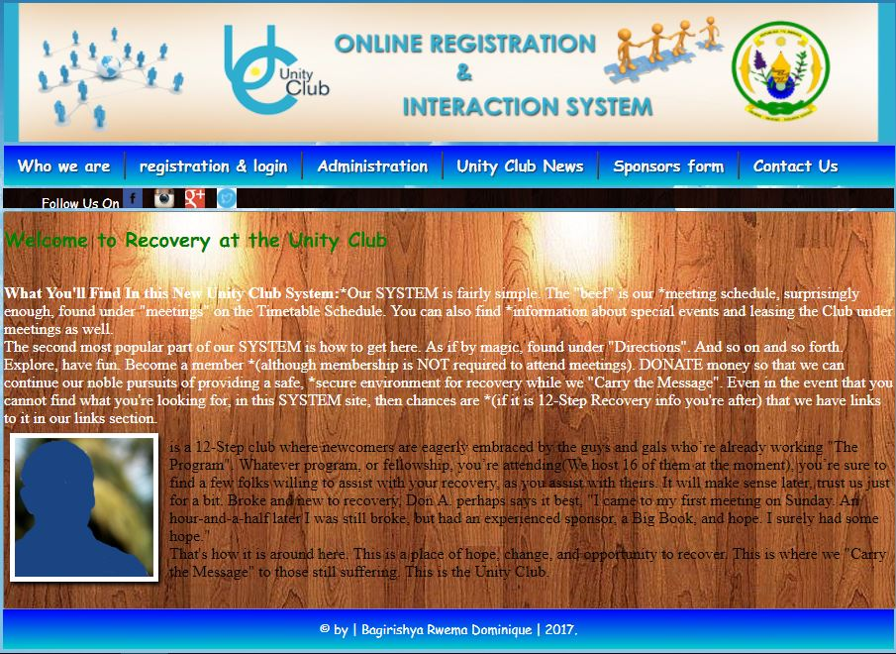

Figure 4homepage

*This is homepage a visitor started on, when he/she visit this site.*

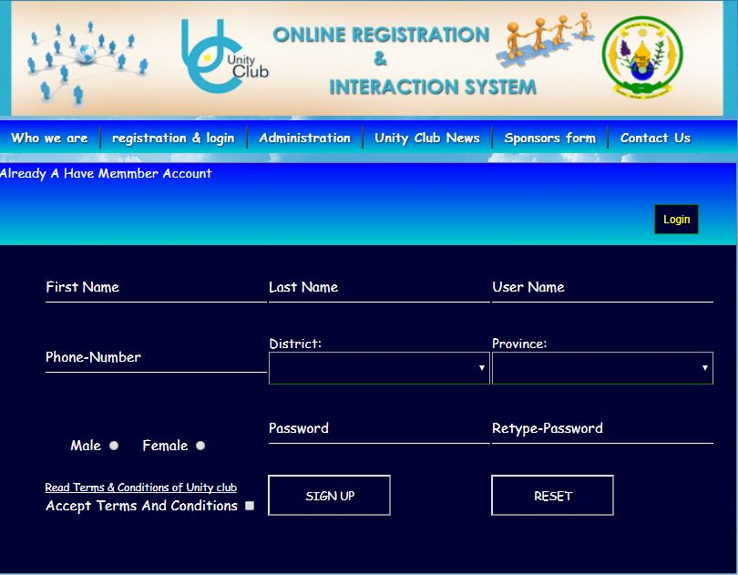

Figure 5registration form

*The figure above indicates the requested forms to fill in where a person who want to become a member will fulfill and then get account in this system.*

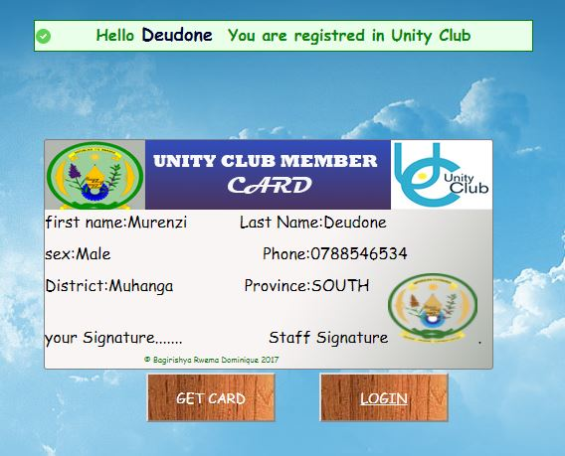

Figure 6registered member successes and getting CARD

*This figure representing the* ***CARD*** *that the system gives member after signup in system (creating accounts or registration) and when he/she presses get card button it will print the card in form suitable to cards. The message above comes to welcome a member when registration compete successful.*

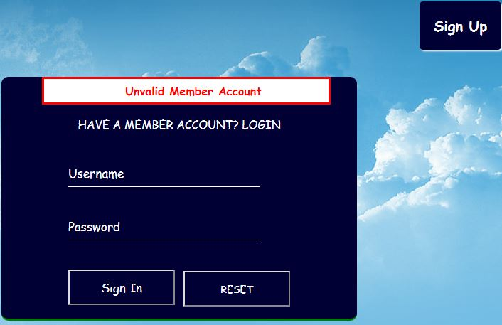

Figure 7unknown information of member that failed to loggin

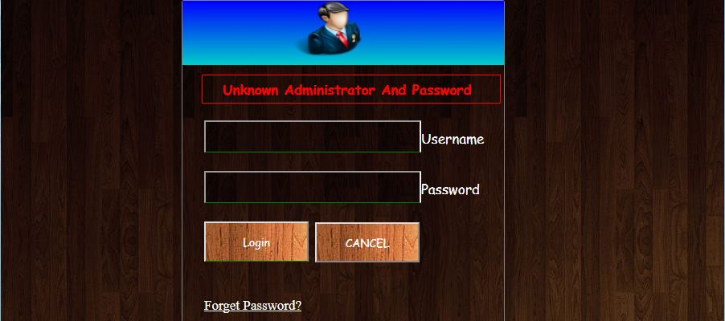

Figure 8 administratior failed to loggin becouse the information is unknown.

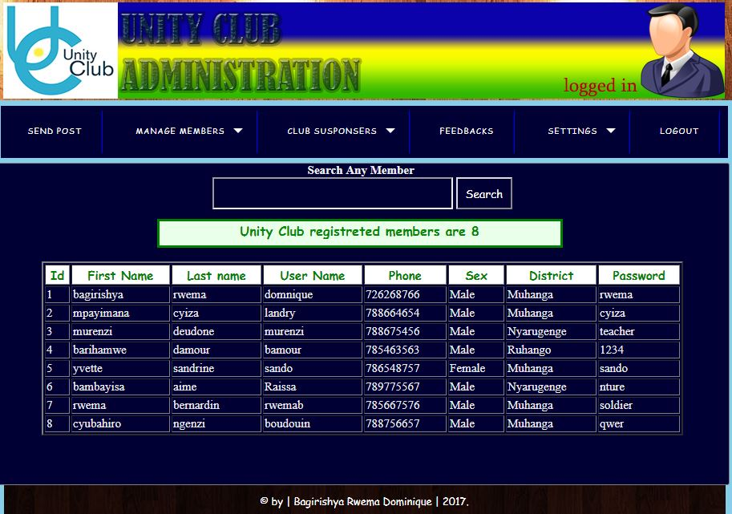

Figure 9 members list

*This figure representing the list of all members in our system. here this system is counting all of members After it displays the total (as it shown above).* ***Here is in administrator interface or (admin is logged in).***

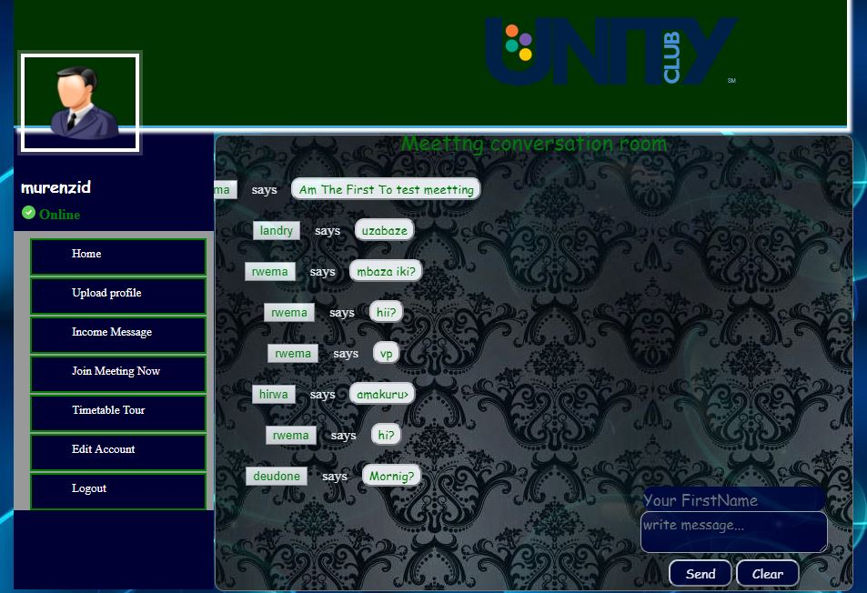

Figure 10member in who is logged in is in charting room

*This picture indicates the charting room where a member logging in and starts* ***compose*** *the messages to others that are online.*

***Here is in member account interface or (one member is logged in).***

# CHAPTER V. CONCLUSION AND RECOMANDATION

## V.1 Conclusion

During the period of developing this system, I plan a better way, and after I analyze a system that will bring a possible way to all people who want to register in Unity Club, a better way of signing up in the system that will be controlled by Administration unity club. Then after this system will provide the interaction and promote relationship between members and Administration of Unity Club, and even members of such area to the others of another area to easy communicate.

Due to what I wanted to achieve, my project was successfully finished as how it is needed concerned on my level of education and knowledge.

## V.2 Recommendations

In Developing This project, I have met with some problems that’s why I recommend to Government and School the following authorities:

To improve the way of bringing all needed information about case studies, like letters, books and other resources (such like increasing computer laboratories) to the student.

To improve and increase bandwidth of internet like (4Glte) in every area of the country not only in zone of cities.

I encourage my previous computer scientist’s young brothers and sisters to Add more functionalities that may led the increase of these final year projects more important.

**BIBLIOGRAPHY**

**Electronic references**

<https://google/wiki/Information_technology>

<https://en.wowslider.org/wowslider/System>

[**https://www.techopedia.com/definition/5547/primary-key**](https://www.techopedia.com/definition/5547/primary-key)

[https:/info@unityclurwanda.rw/home](https://searchsqlserver.techtarget.com/definition/database)

[https://whatis.techtarget.com](https://whatis.techtarget.com/)

<https://searchsoa.techtarget.com/definition/table>

**BOOKS AND PUBLICATIONS**

* Database notebook for s5 and s6
* Web design notebook for s5 and s6
* System analysis notebook